14 July 2016
PHROC Calls for the Immediate Release of Hunger Striking Administrative Bilal Kayed
The Palestinian Human Rights Organizations Council (PHROC) calls for the immediate release of hunger striking administrative detainee Bilal Kayed, who has been on hunger strike for 30 days. We have been informed by attorneys that Mr. Kayed has refused to undergo any medical examinations and to take any vitamins or salt supplements. He is currently only consuming water. He feels tiredness, dizziness, weakness, and inability to fall asleep. His weight has fallen significantly since his hunger strike. Mr. Kayed’s health severely deteriorates and will be transferred to a hospital. Mr. Kayed has lost consciousness due to his health condition.
Bilal Kayed, a 35-year-old Palestinian from Nablus, was arrested in 2001 and sentenced to 14-and-a-half years. He was previously placed in isolation in Rimon prison since September 2015 until his scheduled release on 13 June 2016. However, a six-month administrative detention order was issued against him on the same day of his scheduled release, immediately after which he was placed back in isolation. Mr. Kayed has been on hunger strike since 15 June 2016 in protest of his detention without charge or trial.
The Israeli occupation policy of administrative detention is used in a widespread and systematic manner, which violates international human rights and humanitarian law. Administrative detention can be only usedinemergency situations, but requires that the authorities follow basic rules for detention, including a fair hearing at which the detainee can challenge the reasons for his or her detention. These minimum standards of due process have been clearly violated in Mr. Kayed’s case, leaving him without any legitimate legal means to defend himself. The military court's order of administrative detention without having any clear evidence or conducting a serious investigation about the credibility of the information used against Mr. Kayedis arbitrary and contrary to relevant international norms and conventions; especially Article 78 of the Fourth Geneva Convention.
PHROC holds that the use of administrative detention as a policy practiced by Israel, the occupying Power, is systemic and arbitrary, in contravention with international law. The use of administrative detention has attracted widespread condemnation from local and international organizations as a violation of fundamental human rights. Therefore, PHROC calls on all international organizations, including the United Nations, the International Committee of the Red Cross, the European Union, and all High Contracting Parties to the Fourth Geneva Convention, to fulfill their obligations towards protecting human rights and enforcing the implementation of international humanitarian law, especially when grave breaches are being perpetrated in times of conflict and occupation. We call for pressure on the Israeli government to immediately release Mr. Kayed and end the use of administrative detention. PHROC affirms concluding observations of the United Nations Committee Against Torture (CAT), 13 May 2016, which called on the Israeli government to “[t]ake the measures necessary to end the practice of administrative detention and ensure that all persons who are currently held in administrative detention are afforded all basic legal safeguards.” PHROC calls for administrative detention, as practiced by the Israeli authorities, to be recognized as a form of psychological torture that should be prohibited in line with the UN Convention Against Torture.

-END-

Palestinian Human Rights Organizations Council
 | Addameer Prisoners’ Support and Human Rights Association  Sahar Francis  General Director |  |  | Aldameer Association for Human Rights  HalaJaber  General Director
 | Al-Haq  ShawanJabarin  General Director |  |  | Al Mezan Center for Human Rights  IssamYounis  General Director
 | Badil Resource Center for Palestinian Residency and Refugee Rights  NidalAzza  General Director |  |  | Defence for Children International - Palestine Section  Khaled Kuzmar  General Director
 | Ensan Center for Human Rights and Democracy  HasiebNashashibi  General Director |  |  | Hurryyat - Centre for Defense of Liberties and Civil Rights  Helmi Al-Araj  General Director
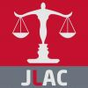 | Jerusalem Center for Legal Aid and Human Rights  IssamAruri  General Director |  |  | Ramallah Center for Human Rights Studies  Suhaib Sharif  General Director
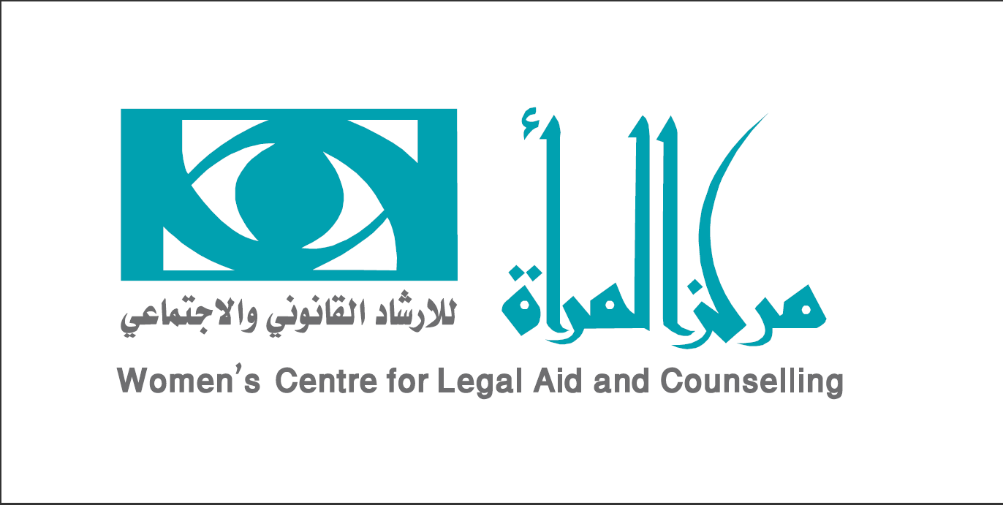 | Women’s Centre for Legal Aid and Counselling  RandaSanyora  General Director |  |  | The Palestinian Center for Human Rights  RajiSourani  General Director

